**Bulb Demo Project**

In this project we are going to light the bulb from remote location using web services. In this we are going to use one raspberry pi interfacing with 12 bulb using 3 relay module with low level trigger. We can trigger the relay from anywhere in the world using a website in which we’ll have 16 GUI Button. In each trigger of relay the correspondence Bulb or group of bulb will glow.

**Hardware Used:**

* Raspberry pi 3
* Relay Module
* 12 led Bulbs

**Raspberry Pi 3 pin block diagram:**

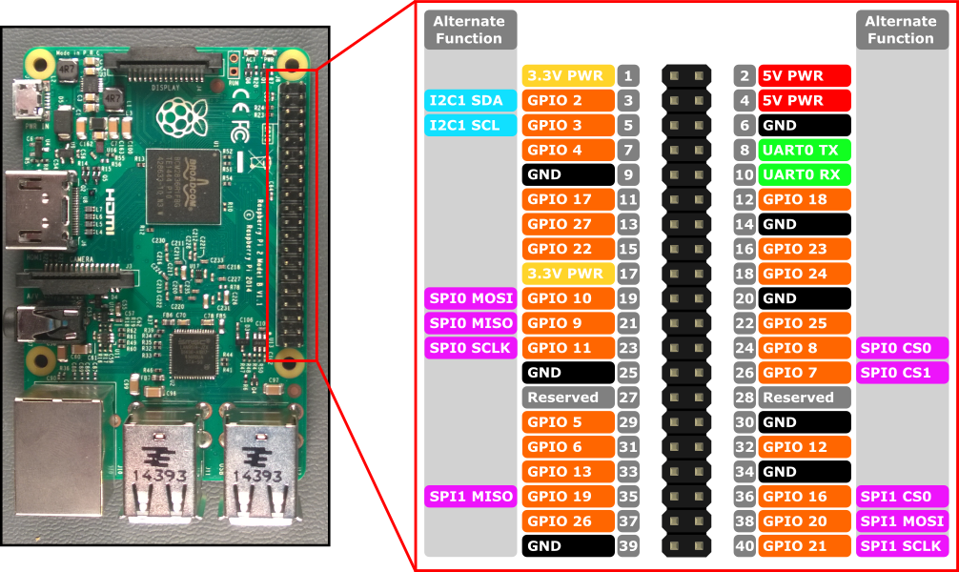

**Brief Description of Raspberry Pi**:

* This is the latest version of raspberry pi. In this we have inbuilt Bluetooth and wi-fi, unlike previously we have to use Wi-Fi dongle in one of its usb port. There are total 40 pins in RPI3.  Of the 40 pins, 26 are GPIO pins and the others are power or ground pins (plus two ID EEPROM pins.)
* There are 4 USB Port and 1 Ethernet slot, one HDMI port, 1 audio output port and 1 micro usb port and also many other things you can see the diagram on right side. And also we have one micro sd card slot wherein we have to installed the recommended Operating system on micro sd card.
* There are two ways to interact with your raspberry pi. Either you can interact directly through HDMI port by connecting HDMI to VGA cable, and keyboard and mouse or else you can interact from any system through SSH(Secure Shell). (For example in windows you can interact from putty ssh.)

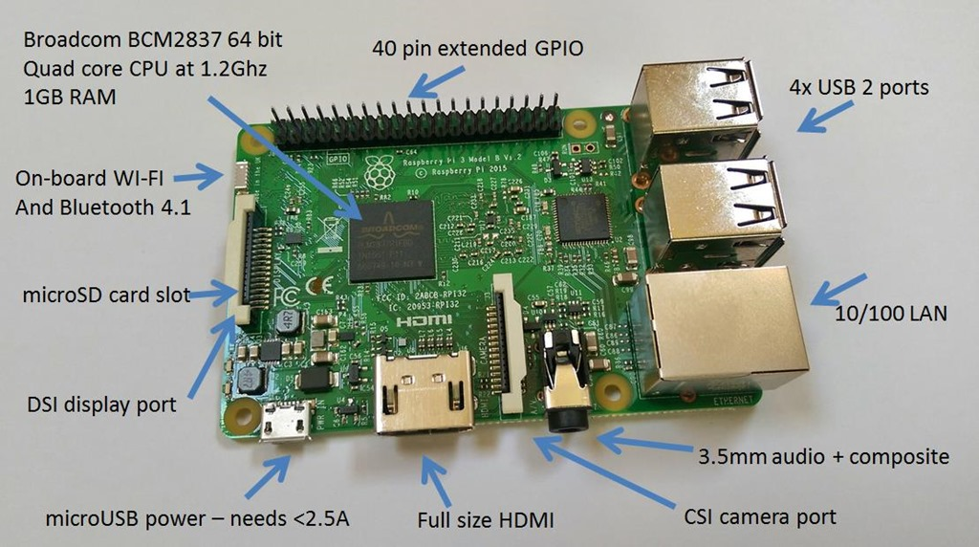

**Relay Module:**

We have used 3 four channel relay module to control 12 led bulbs. As we are working with 220 volt ac we have to make sure that our connection are properly connected.

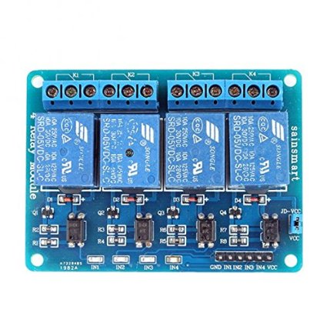

**Circuit diagram for Relay and Raspberry pi:**

For complete isolation with microcontroller we can wire up our circuit as below. Here we have to remove jumper used in jd-vcc and vcc



Bulb connection with relay and raspberry pi 3:

* Here we are connecting our relay to one single Bulb. In this there is no optical isolation we can make it by removing jumper from vcc and jd-vcc. And by giving separate power supply to Jd-VCC as shown in previous slide.

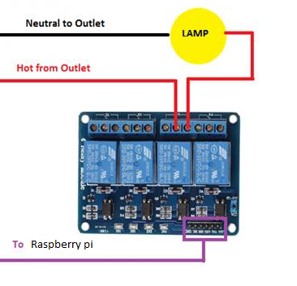

As below the diagram I’ve just shorted all the com pin of relay and from NO we've taken wire which is going to the entire bulbs one terminal and from the second terminal of bulb it will go to the ac main and the hot line of the ac will be coming from the shorted com pin of relay.

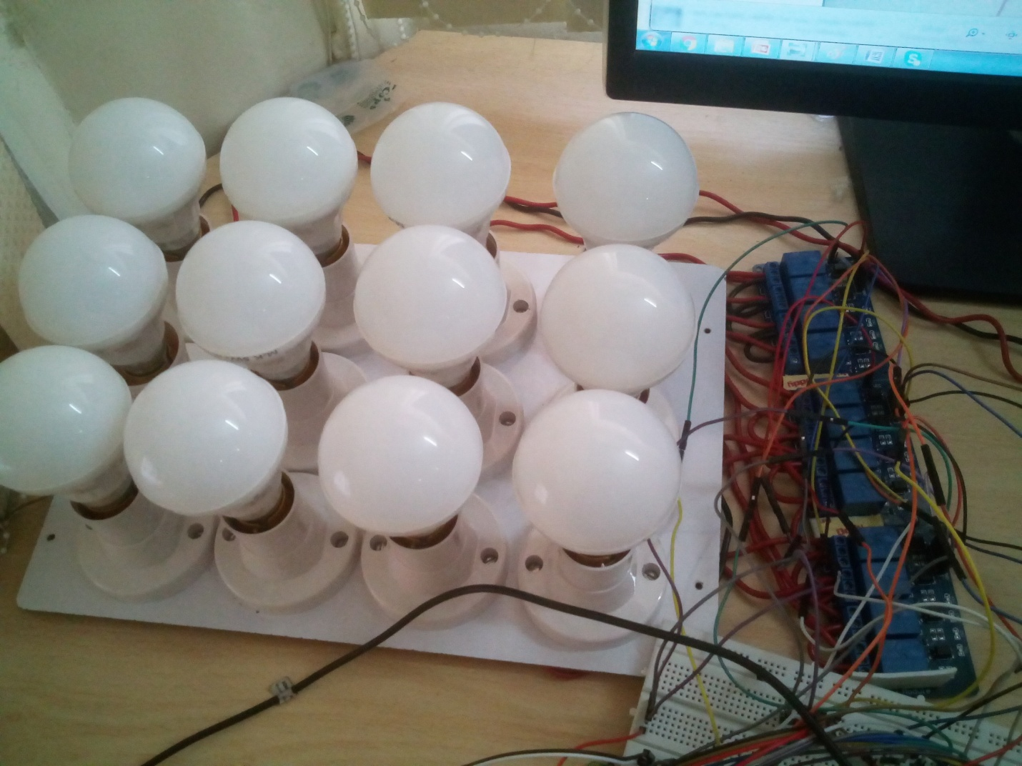

Software Used:

* Raspbian OS: This is the recommended os for raspberry pi. You can also installed other OS from third party. Raspbian OS is debian based OS. We can install it from noobs installer.
* Python idle: This is the software we get in raspbian os. For this project we have used python script.
* Pagekite: This is the tool to make a local website publically accessible. We’ve used this to make our local website and ssh servers accessible to any network.